Guided Practice Report
Before completing this guided practice report, you should have completed the associated procedure.

Screenshots
After you have completed the procedure for the guided practice, add your screenshots below.
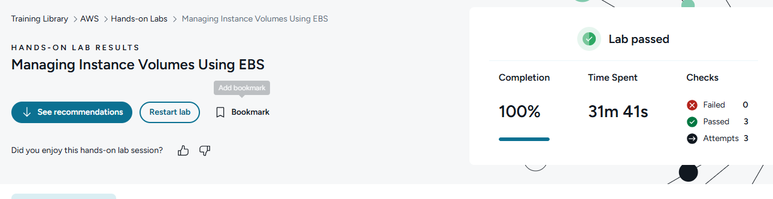

Reflection Questions
After you have completed the procedure for the guided practice, provide your answers to the reflection questions here.
Why should you use EBS to store user-created data instead of simply using the instance store available on your EC2 instance?
EBS keeps your data even if the EC2 instance stops or terminates. Instance store is temporary and vanishes like digital fog when the instance is gone.

Why was it important to assign your created EBS volume to the same Availability Zone (AZ) as your EC2 instance?
An EBS volume can only attach to an EC2 instance in the same AZ, so they must match.

Why might you choose to detach an EBS volume from the EC2 instance it is attached to?
To move it to another EC2 instance, troubleshoot, resize, back it up, or keep the data while replacing the instance.

What is an EBS Snapshot for?
It is a backup copy of an EBS volume, usually stored in Amazon S3, used to restore data or create new

